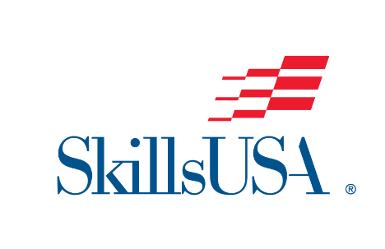

Name/Organization

Address Line 1

Address Line 2

City, State, Zip

**Phone:** 000-000-0000

**Email:** [enter email address]

**Web:** [enter web address]

Dear [Administrator Name],

I am writing to request your continued support of our [School/College Name] SkillsUSA chapter. We can’t succeed without the backing of our school administrators who make CTE and CTSOs a priority. I am delighted to share with you more about our school’s SkillsUSA chapter so we can strengthen our partnership with leadership and continue to make a difference for our students!

SkillsUSA is America’s proud champion of the skilled trades. Their mission is to empower students to become skilled professionals, career-ready leaders and responsible community members. Every aspect of SkillsUSA programming is built around the SkillsUSA Framework, which emphasizes Personal Skills, Workplace Skills and Technical Skills grounded in academics. The Framework actualizes opportunities for students and identifies the career readiness skills needed to be successful on the first day of the job. SkillsUSA also provides free virtual professional development for our instructors throughout the year to maximize results. I hope you can see the impact that SkillsUSA has on our students and faculty!

## 

## **Our Chapter:**

2025 Members: [Number of members]

2025 Advisors: [List advisors by name]

2025 SkillsUSA Chapter Excellence Program: [Quality, Bronze, Silver or Gold]

2025 SkillsUSA competitors: [Local, State and National]

2025 SkillsUSA medalists: [Local, State and National]

SkillsUSA Community Engagement: [Summarize recent chapter community service activities]

We invite you to attend an upcoming chapter meeting or activity to see our members in action. If you have any questions about the chapter, please let me know.

We are grateful for your continued support,

[Name]