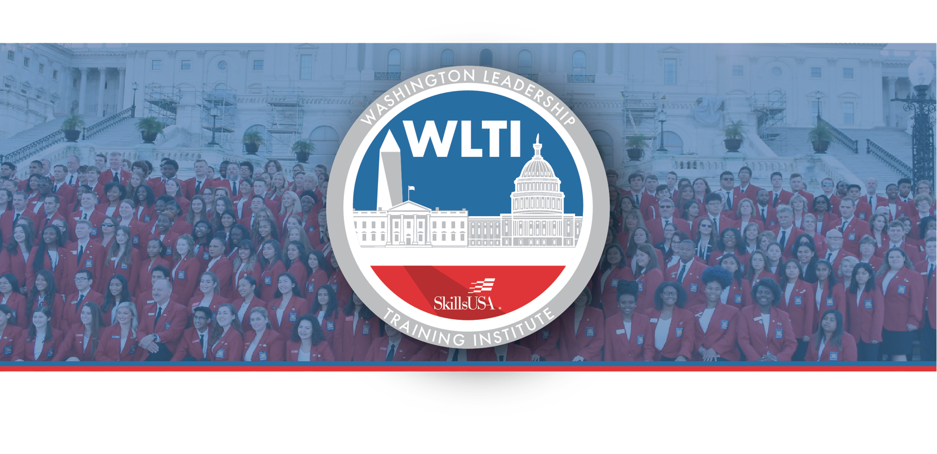

Dear WLTI Delegation Leader:

This is important background information for your Sept. 26, 2023 congressional visits along with follow-up information.

BEFORE YOUR VISITS
Please review the following information with your delegation members during the state planning session on Monday, Sept. 25.

Safety, Security and Tour Tips for Capitol Hill

House and Senate CTE Caucus and Committee Lists — These are the Members of Congress who have the most influence over career and technical education.

2022 WLTI Congressional Visit Report — This report from the last WLTI lists who each state met with in 2022 and summarizes their visit.

CONGRESSIONAL VISIT MATERIALS

Each state has been provided with a set of leave-behind materials for your visits. Extra materials are available in WLTI Headquarters, if needed. Packets include:

- SkillsUSA Advocacy Brochure
- List of Delegation Members — Create a delegation list to leave with the congressional representative or senator so they have a record of who visited. A fillable PDF is available.
- SkillsUSA Notecards — Send a thank-you card after your visit.

DELEGATION TASKS TO COMPLETE AFTER YOUR VISIT
- 2023 Congressional Visit Report Form — Assign one person to complete an online report form for each meeting. List your state, the name of the Representative or Senator, the person you met with and a brief visit summary.
- Thank-you note — Assign one person to write a thank-you card on behalf of your group to mail to the representative or senator. A sample thank you note is on the SkillsUSA WLTI webpage.
- WLTI Press Release — WLTI attendees should send a press release to their local newspaper upon returning home. A fill-in press release is on the WLTI webpage and on the SkillsUSA advocacy site. After the release is submitted, follow-up with the media by calling or emailing.

Deadline: Complete the Congressional Visit Report Form online and the thank-you notes as directed. Drop off your unsealed thank-you notes to the WLTI Headquarters so they can be reviewed and mailed for you.

Read the latest WLTI updates.

